

System Analysis and Design

Final Assignment

School of Software Class 2021 Group T13

目录

I. The design approach and the contribution of each team member 3

II. design objectives and principles 4

III. Requirements captured 5

IV. Use case modelling 6

V.User Interface 16

VI. Class Diagram 21

VIII. Persistence data ER diagram (Persistence data) 29

IX. Application deployment diagram 30

# I. **The design approach and the contribution of each team member**

The main system analysis and design is done with UML tools using an object-oriented design strategy.

1. Define the purpose of the design.
2. Analyse what functions the system needs to perform in order to achieve these aims, and on this basis draw use case diagrams and write use case statutes.
3. Draw a class diagram and analyse the relationship between the classes.
4. Draw a sequence diagram.
5. Determine the design of the database based on the identified classes and the links between classes.
6. Complete the general design of each interface.

Based on the design work, the team members were divided as follows:

Team leader: 朱家顺

1. The design approach and the contribution of each team member: 朱家顺
2. Design objectives and principles: 朱家顺
3. Needs Analysis: 苏琪超
4. Use Case Modelling: 翟启发, 苏沛泽
5. User interface: 朱家顺, 蔡宏天
6. Class picture: 李亦语
7. Sequential picture: 陈俊言, 蔡宏天
8. Persistence data ER diagram: 苏沛泽, 公令适
9. Application deployment diagram: 林志超, 张长兴

# **II. design objectives and principles**

Design Objective:

Design an online web application that can run on Windows, with a registration period that allows provincial leagues to register for tournaments by entering provincial league information, selecting tournament categories and levels during the open registration period, connect the designed system to the two banking systems used by the provinces and conference organisers to process payments and refunds of registration fees, and provide functionality that allows provincial leagues to readily print registration records for participating tournaments.

Design principles:

Simplicity: The user interface is designed to be simple and intuitive, so that the league can easily understand and use the system without the need for cumbersome training.

Data accuracy: data validation and verification are carried out to ensure the accuracy and completeness of registration information.

Integration: the design system is connected to two banking systems to enable payment of registration fees and refund operations.

Searchability: Provides a search function that enables the registration administration of sports competition organisers to search for matches registered in a provincial league (category and level) and which provincial leagues have registered a particular match (category and level).

Scalability: Design a scalable system that can easily add new competition categories, levels and features to accommodate changing competition needs.

Data security: Appropriate security measures, such as data encryption and access control, are in place to protect sensitive information from unauthorised access and disclosure.

Efficient: design the system to achieve an efficient registration process and query response time to provide a good user experience.

Maintainability: The design system is easy to maintain and update, allowing for easy fixes and functional improvements.

Reliability: Ensures system stability and reliability, preventing data loss and system failure.

# **III. Requirements captured**

Provincial sports teams can do the following during registration:

1. Provincial sports teams need to provide the name, address, ID of the sports team, and names of the members of the sports team.

2. Select the registered game category (basketball, volleyball, rugby) and level (beginner, intermediate, advanced).

3. deregistration.

Note:

* The registration application should be obtained during the registration period, and the registered provincial league ID should be obtained after registration.
* Registration fee is required to register for the competition.
* Cancellation of registration and refund of the full registration fee.

Provincial sports teams can do the following after registration:

1. Increase the number of matches.

2. Delete the match.

3. Check and print your registration record for participating in the competition.

Note:

* To add and delete matches, you need to provide the ID of the provincial league and select the category and level of the game.
* After the end of the registration period, each sports team can only cancel the entire competition and receive a refund of half of the registration fee.
* The registration fee will be adjusted accordingly after the increase and deletion of the competition.
* There will be no refunds after the start of the competition.

Sports contest organizers can query and print out:

1. What competitions (categories and levels) are registered for a province's sports teams.
2. Which provincial leagues have registered for a certain competition (category and level).
3. Who is the referee of a certain game.
4. Which match the referee is assigned to.

# **IV. Use case modelling**

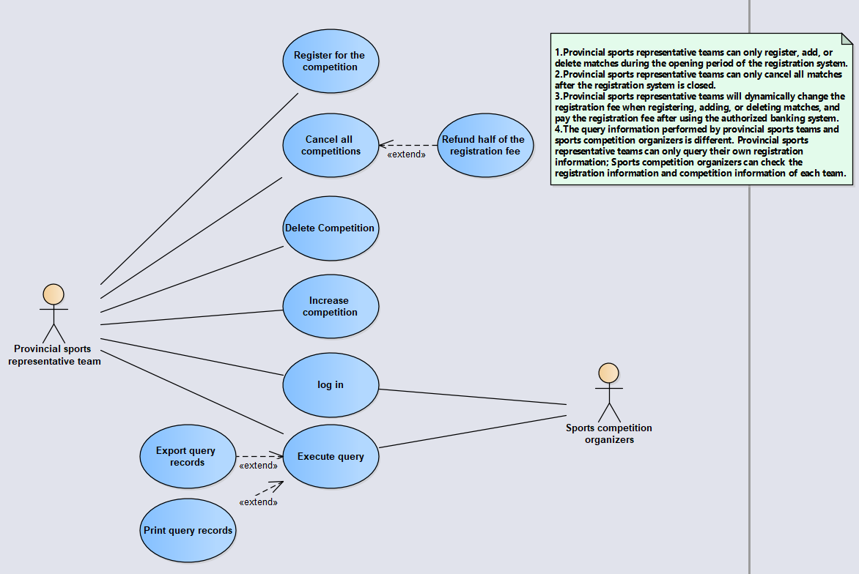

Use Case Description (Use Case Statute document)

|  |  |
| --- | --- |
| Use Case A:Log in | |
| Use case name | This use case describes the process of a user logging into a registration system to authenticate the user and gain access to the system. |
| Participants | Organizer of provincial sports teams and sports competitions |
| Pre-requisites | The user already has an account and password for the registration system. |
| Post-condition | The user successfully logs in to the system and obtains system access rights. |
| Basic event flow | 1. The user opens the login page of the registration system. 2. The user enters a valid username and password. 3. The user clicks the login button. 4. The system verifies that the username and password entered by the user match. 5. The system authenticates the user successfully, and jumps to the system home page, displaying user-related information and operation options. |
| Alternative event streams | 4a. The username or password entered by the user is empty：  4a1.The system prompts the user for a username and password.  4a2.The user returns to step 2 to re-enter.  4b. The username entered by the user does not exist or the password is wrong：  4b1.The system prompts that the user name entered does not exist or the password is wrong, please re-enter  4b2.The user returns to step 2 to re-enter. |
| Extension points | 1. User forgot password： 2. The user clicks on the "forgot password" link. 3. The system jumps to the password reset page, and the user follows the system prompts to reset the password. 4. After the user successfully resets the password, return to the login page to log in again. |
| Input data | 1. Username: A valid username, used for authentication. 2. Password: The password corresponding to the username. |
| Output data | 1. User related information and action options. |
| Non-functional requirements | 1. Security: User passwords should be stored and transmitted with security measures, such as encrypting passwords using a hash algorithm. 2. User experience: A friendly interface and appropriate error prompts should be provided so that users can accurately understand the reasons for login failures. |

|  |  |
| --- | --- |
| Use Case B:Register for the competition | |
| Use case name | This use case describes the process that a provincial sports team selects a competition category and level during registration and completes the corresponding competition registration process. |
| Participants | Provincial sports team |
| Pre-requisites | The provincial sports team has logged into the system and is in the registration period. |
| Post-condition | The provincial sports representative team successfully registered for the competition and obtained the corresponding competition ID. |
| Basic event flow | 1. Provincial sports teams enter the registration league page. 2. Provincial Sports Team Enter the name of the sports team, address, sports team ID and names of the sports team members. 3. Provincial sports teams choose the category of competition (basketball, volleyball, rugby) and level (junior, intermediate, senior). 4. After the provincial sports representative team confirms that the selected game information is correct, click the registration button. 5. The system verifies the validity of the registration information. 6. The system generates and assigns a unique provincial league ID to the sports team. 7. The system calculates the registration fee according to the competition category and level, and prompts the provincial sports team to pay the registration fee. 8. Provincial sports team completes registration fee payment 9. The system confirms that the registration fee has been paid successfully, and adds the sports representative team to the corresponding competition participant list. |
| Alternative event streams | 5a. Registration information is missing or illegal：  5a1.The system prompts missing or illegal registration information, requiring the provincial sports team to re-enter or complete.  5a2.Provincial sports teams return to step 2 to re-enter or supplement registration information.  7a. Registration fee payment failed：  7a1.The system prompts that the payment has failed, provides relevant payment methods and guidelines, and requires the provincial sports team to make a new payment.  7a2.Provincial sports teams return to step 8 to repay the registration fee. |
| Extension points | 1.deregisteration：  1).Provincial sports teams have the option to deregister during registration.  2)After canceling the registration, the system will refund all registration fees to the provincial sports team. |
| Input data | 1.Sports team name, address, sports team ID, sports team member names.  2.Game category (basketball, volleyball, football) and level (junior, intermediate, senior). |
| Output data | 1.Provincial League ID and Registration Fee |
| Non-functional requirements | 1.Security: User passwords should be stored and transmitted with security measures, such as encrypting passwords using a hash algorithm.  2.User experience: should provide a friendly interface and appropriate prompts |

|  |  |
| --- | --- |
| Use Case C:increase competition | |
| Use case name | This use case describes the process of adding competitions to a provincial sports team after registration is complete. |
| Participants | Provincial sports team |
| Pre-requisites | The provincial sports team has logged into the system and is in the registration period. |
| Post-condition | Successfully add competitions and adjust registration fees accordingly. |
| Basic event flow | 1. Provincial sports teams enter the competition management page. 2. Provincial sports teams have chosen to add competition options. 3. Provincial sports teams provide the ID of the provincial league and choose the category and level of competition. 4. The system verifies the legitimacy of the information provided. 5. The system adds game information and calculates the corresponding registration fee. 6. After the provincial sports team confirms that the game information and registration fee are correct, click the Confirm button. 7. The system updates competition information and registration fees. |
| Alternative event streams | 4a. The information provided is illegal：  4a1.The system prompts that the information provided is illegal and requires the provincial sports team to re-enter legal information.  4a2.Provincial sports teams return to step 3 to re-provide legitimate information. |
| Extension points | None |
| Input data | 1. The ID of the provincial league. 2. Category and level of competition. |
| Output data | 1. Adjusted Fee |
| Non-functional requirements | 1. Security: User passwords should be stored and transmitted with security measures, such as encrypting passwords using a hash algorithm. 2. User experience: A friendly interface and appropriate prompts should be provided so that participants can operate conveniently and quickly. |

|  |  |
| --- | --- |
| Use Case D:delete competition | |
| Use case name | This use case describes the process for a provincial sports team to delete a game after registration is complete. |
| Participants | Provincial sports team |
| Pre-requisites | The contest is successfully removed and the registration fee is adjusted accordingly. |
| Post-condition | The contest is successfully removed and the registration fee is adjusted accordingly. |
| Basic event flow | 1.Provincial sports teams enter the competition management page.  2.The provincial sports team chose to delete the competition option.  3.Provincial sports teams provide the ID of the provincial league and select the category and level of competition to be removed.  4.The system verifies the legitimacy of the information provided.  5.The system deletes the competition information and calculates the corresponding registration fee.  6.After the provincial sports team confirms that the game information and registration fee are correct, click the Confirm button.  7.The system updates competition information and registration fees. |
| Alternative event streams | 4a. The information provided is illegal：  4a1.The system prompts that the information provided is illegal and requires the provincial sports team to re-enter legal information.  4a2.Provincial sports teams return to step 3 to re-provide legitimate information. |
| Extension points | None |
| Input data | 1. The ID of the provincial league. 2. The category and level of the contest to delete. |
| Output data | 1. Adjusted Fee |
| Non-functional requirements | 1. Security: User passwords should be stored and transmitted with security measures, such as encrypting passwords using a hash algorithm. 2. User experience: A friendly interface and appropriate prompts should be provided so that participants can operate conveniently and quickly. 3. The system should ensure the reliability of the delete operation, ensure the accuracy of the delete operation and the consistency of the data. |

|  |  |
| --- | --- |
| Use Case E:cancel all competitions | |
| Use case name | This use case describes the process for a provincial sports team to cancel all games after registration is complete. |
| Participants | Provincial sports team |
| Pre-requisites | The provincial sports team has logged into the system and successfully registered for the competition. |
| Post-condition | The system updates the corresponding competition information and cancels all competitions of provincial sports teams. |
| Basic event flow | 1. Provincial sports teams log in to the system. 2. Provincial sports teams enter the personal account page. 3. Provincial sports teams opted to cancel all competitions. 4. The system displays a message confirming the cancellation of all matches. 5. Provincial sports teams confirmed the cancellation of all competitions. 6. The system updates the competition information and cancels all competitions of provincial sports teams. 7. The system displays a message indicating that the match has been canceled successfully. |
| Alternative event streams | None |
| Extension points | None |
| Input data | 1. The ID of the provincial league. 2. Identification information of provincial sports teams |
| Output data | 1. The prompt message displayed by the system to cancel the game successfully 2. Updated game information |
| Non-functional requirements | 1. Security: User passwords should be stored and transmitted with security measures, such as encrypting passwords using a hash algorithm. 2. User experience: A friendly interface and appropriate prompts should be provided so that participants can operate conveniently and quickly. 3. The system should verify the cancellation of the game to ensure that only the provincial sports team can perform the operation. 4. The system should record the operation log of canceled games for follow-up tracking and auditing. |

|  |  |
| --- | --- |
| Use Case F:Refund half of the registration fee | |
| Use case name | This use case describes that if a provincial sports team cancels all competitions after the registration is completed, the system will refund half of the registration fee |
| Participants | Provincial sports team |
| Pre-requisites | 1. The provincial sports team has logged into the system and successfully registered for the competition. 2. All games canceled |
| Post-condition | The system will carry out refund processing and return half of the registration fee to the provincial sports representative team. |
| Basic event flow | 1. Provincial sports teams log in to the system. 2. Provincial sports teams enter the personal account page. 3. Provincial sports teams choose the option of refunding half of the registration fee. 4. The system displays a prompt message confirming the refund of half of the registration fee. 5. The provincial sports team confirmed that half of the registration fee will be refunded. 6. The system will carry out refund processing and return half of the registration fee to the provincial sports representative team. 7. The system displays a message indicating that the refund is successful. |
| Alternative event streams | None |
| Extension points | None |
| Input data | 1. The ID of the provincial league. 2. Identification information of provincial sports teams |
| Output data | 1. The prompt message of successful refund displayed by the system 2. refund amount |
| Non-functional requirements | 1. Security: User passwords should be stored and transmitted with security measures, such as encrypting passwords using a hash algorithm. 2. User experience: A friendly interface and appropriate prompts should be provided so that participants can operate conveniently and quickly. 3. The system should record the operation log of refunding half of the registration fee for follow-up tracking and auditing. |

|  |  |
| --- | --- |
| Use Case G:execute query | |
| Use case name | Query competition information means that provincial sports teams and sports competition organizers can query and print relevant competition information through the system, including competitions participated by provincial sports teams, participation in provincial leagues of a certain competition, and host of a certain competition. Referees and referee assignments. |
| Participants | Provincial sports teams and sports competition organizers |
| Pre-requisites | 1. A participant is logged into the system. 2. Provincial sports teams are registered and have a valid Provincial League ID. |
| Post-condition | The system displays the corresponding game information |
| Basic event flow | 1. A participant logs into the system. 2. Provincial sports teams enter the personal account page, and sports competition organizers enter the management page. 3. The provincial sports representative team chooses the option to query the competition they participate in, and the sports competition organizer chooses the corresponding option to query the competition information (only information within the authority can be checked). 4. The corresponding conditions for the provincial sports team to input the provincial league ID and the sports competition organizer to input the competition information. 5. The system queries the corresponding game information according to the input conditions. 6. System display information |
| Alternative event streams | None |
| Extension points | None |
| Input data | 1. Participant's identity verification information 2. Provincial league ID (required when inquiring about provincial sports teams) 3. Conditions for competition information (required for inquiries by sports competition organizers) |
| Output data | 1. The system displays the corresponding information |
| Non-functional requirements | 1. Security: User passwords should be stored and transmitted with security measures, such as encrypting passwords using a hash algorithm. 2. User experience: A friendly interface and appropriate prompts should be provided so that participants can operate conveniently and quickly. 3. The system should record the operation log for querying game information for follow-up tracking and auditing. 4. The system should verify the operation of querying game information to ensure that only authorized participants can perform this operation. |

|  |  |
| --- | --- |
| Use Case H:Export query records | |
| Use case name | Exporting query results means that sports competition organizers or provincial sports teams can export the queried game information as a file or print them out through the system for further analysis or sharing. |
| Participants | Provincial sports teams and sports competition organizers |
| Pre-requisites | 1. A participant is logged into the system. 2. The participant has performed the operation of querying the competition information and obtained the query result. |
| Post-condition | Query results were exported successfully. |
| Basic event flow | 1. A participant logs into the system. 2. The participant enters the management page. 3. Participants select the option to export query results. 4. The system displays the query results and provides the option to export. 5. Participant selects an export option. 6. The system executes the export operation and generates corresponding files. |
| Alternative event streams | None |
| Extension points | None |
| Input data | 1. Participant's identity verification information 2. Query the records |
| Output data | 1. Query results for exported files |
| Non-functional requirements | 1. Security: User passwords should be stored and transmitted with security measures, such as encrypting passwords using a hash algorithm. 2. User experience: A friendly interface and appropriate prompts should be provided so that participants can operate conveniently and quickly. 3. The system should record the operation log of the exported information for follow-up tracking and auditing. 4. The system should protect the security of exported query results to ensure that only authorized participants can access and use the exported data. 5. The exported files should conform to the appropriate format and structure to facilitate subsequent use and analysis. |

|  |  |
| --- | --- |
| Use Case I:print query records | |
| Use case name | Printing query records means that provincial sports teams and sports competition organizers can print out the query registration records of competitions through the system. |
| Participants | Provincial sports teams and sports competition organizers |
| Pre-requisites | 1. A participant is logged into the system. 2. The participant has performed the operation of querying the competition information and obtained the query result. |
| Post-condition | Query records are successfully printed. |
| Basic event flow | 1. A participant logs into the system. 2. The participant enters the management page. 3. Participant selects the option to print a record of the query. 4. The system displays the query records and provides the option to print them. 5. Participants select the print option. 6. The system executes the print operation and prints out the query records. |
| Alternative event streams | None |
| Extension points | None |
| Input data | 1. Participant's identity verification information 2. Query the records |
| Output data | 1. Printed query records |
| 1. Non-functional requirements | 1. Security: User passwords should be stored and transmitted with security measures, such as encrypting passwords using a hash algorithm. 2. User experience: A friendly interface and appropriate prompts should be provided so that participants can operate conveniently and quickly. 3. The system should record and print the operation log of registration information for follow-up tracking and auditing. 4.The system should perform a print operation and print out the query records in a readable format. 4. The system should provide suitable printing options so that participants can select the appropriate printing settings. |

# **V.User Interface**

1. Login

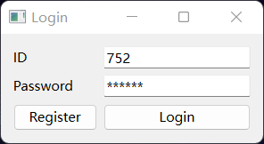

1. Registration

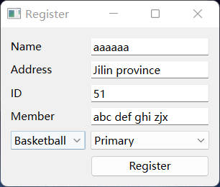

1. The Main interface of the sports team

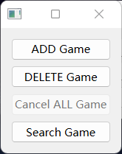

1. Add a game

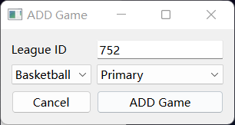

1. Delete a game

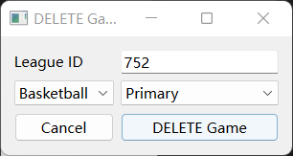

1. Search and print a game

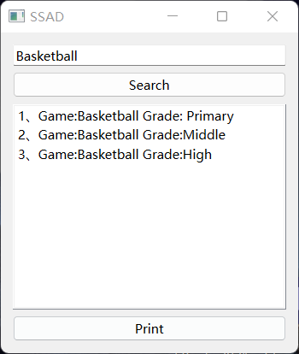

1. The organizer's main interface

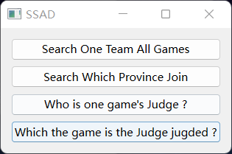

1. Which games are registered for a provincial sports team



1. Which provincial leagues have registered a match

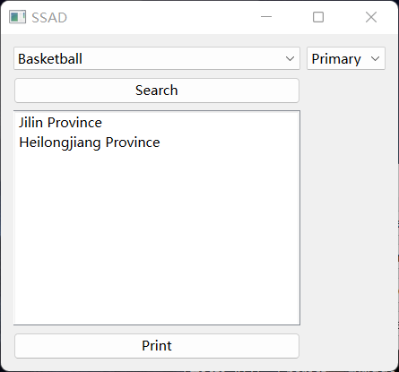

1. Who is the referee of a particular match

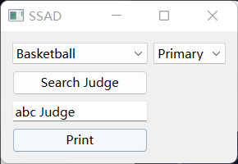

1. Which game the referee is assigned to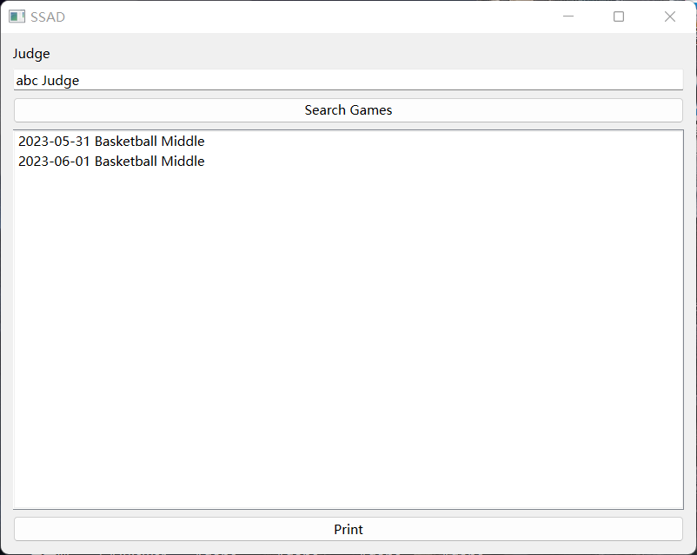

# **VI. Class Diagram**

(a provincial team in a particular sport, with different teams in different sports categories)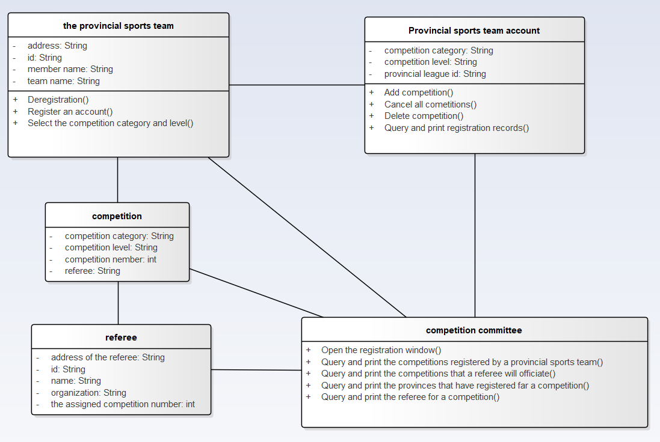

1. The Provincial Sports Team(a provincial team in a particular sport, with different teams in different sports categories)

①Attributes：

id: The id of the provincial sports team. The id represents the province and the category of the competition.

member name: Name of each player, coach and leader of a sports team.

team name: The name of the sports team, which can be personalized.

address: The specific address of the sports team.

② Functions:

Register an account(): The sports team uses this function to register an account belonging to the sports team on the league registration system during the open enrollment period. The registration fee is required to register the account.

Select Competition Category and Level(): Select the competition category (basketball, volleyball, rugby) and level (primary, intermediate, advanced) of the league you want to register for.

Deregistration(): The sports team cancels the registration operation through this function. All registration fees will be refunded if the registration is cancelled.

2. Provincial Team Account (the account that the provincial team gets after registration)

① Attributes:

Provincial league id: The league ID generated after the provincial team is registered.

Competition category: category of sport (basketball, volleyball, rugby) in which the provincial team is registered.

Competition level: The competition level of the league registered by the provincial team (junior, intermediate, senior).

② Functions:

Query and print registration records(): Query and print the registration records of the provincial athletic team as proof of application for refund of registration fee.

Add competition(): To add a competition to a provincial league, you need to provide a provincial league ID.

Delete competition(): To delete a competition, you need to provide your provincial league ID.

Cancel all competitions(): Cancel all competitions added by the team. At the end of the registration period, each team can only cancel all competitions and receive a refund of half of the registration fee.

1. Competition Committee (the Organizing committee of the competition, they can inquire all the information about the competition).

Functions:

Open the Registration window(): Open the registration window to allow provincial teams to register during the registration period allowed.

Query and print the provinces that have registered for a competition(): Find out which provinces have registered a match and can print it.

Query and print the competition that a referee will officiate(): Query the competition that a referee will officiate and print the matches.

Query and print the referee for a competition(): Query the referee of a match and print his information.

Query and print the competitions registered by a provincial team(): Find out which competitions are registered by a provincial team and print them.

4. Competition (competitions registered by provincial teams)

Attributes:

Competition category: Sport (basketball, volleyball or rugby) in which the competition is played.

Competition level: Primary, intermediate or advanced.

Competition number: The number of the competition in that league, and the assigned referee

Referee: Name of the referee who called the game.

5. Referee (the chair judge of the competition, ensuring that the competition is fair and just)

Attributes:

Id: Referee number.

Name: Name of the referee.

Address of the referee: The referee's workplace.

The assigned competition number: The competition number for which the referee will officiate.

Organization: a referee's organization (a referee association or a referee company).

# **VII. Sequence diagram**

1.Login System

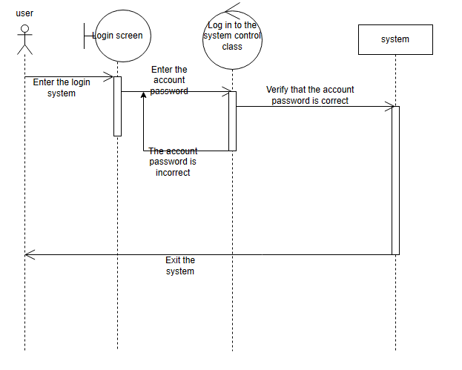

2.Register for the competition

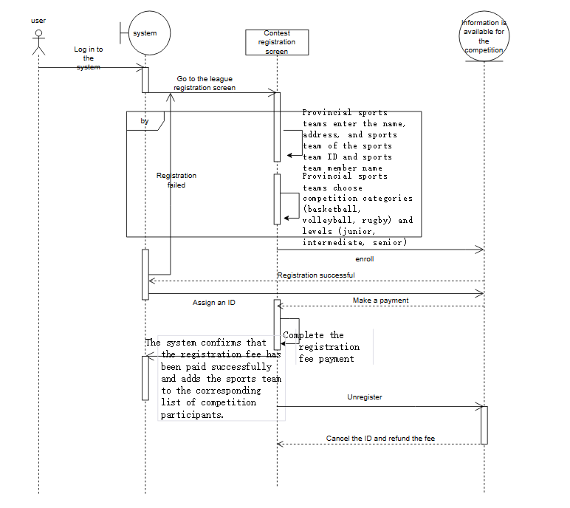

3.Adding competitions

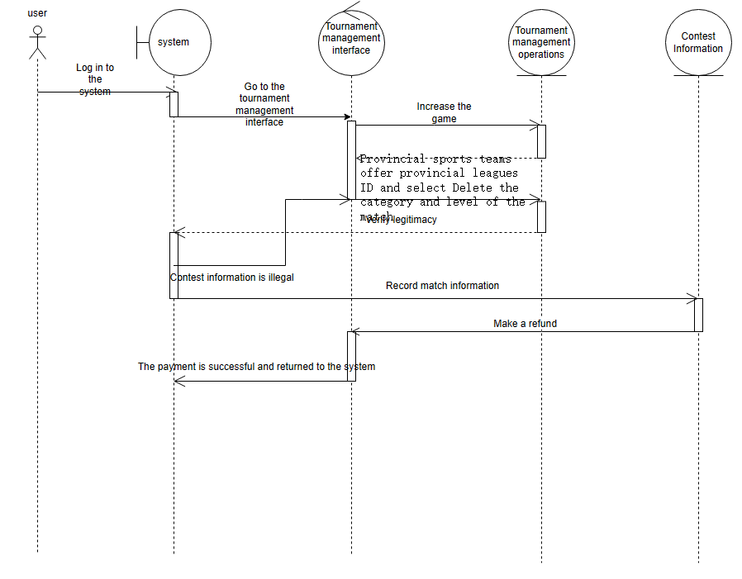

4.Delete Match

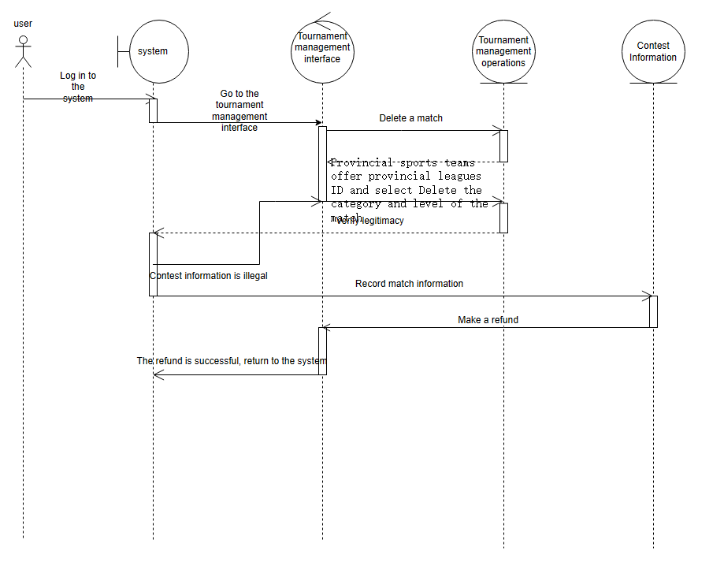

5.Cancellation of all matches

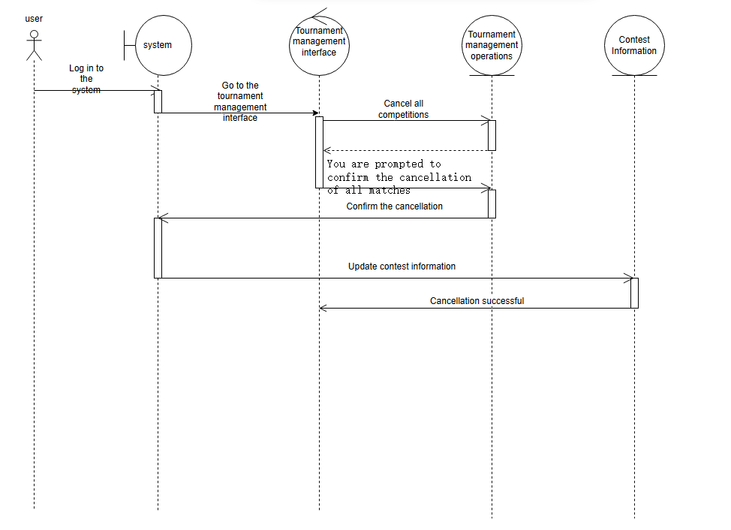

6.Half of the registration fee is refunded

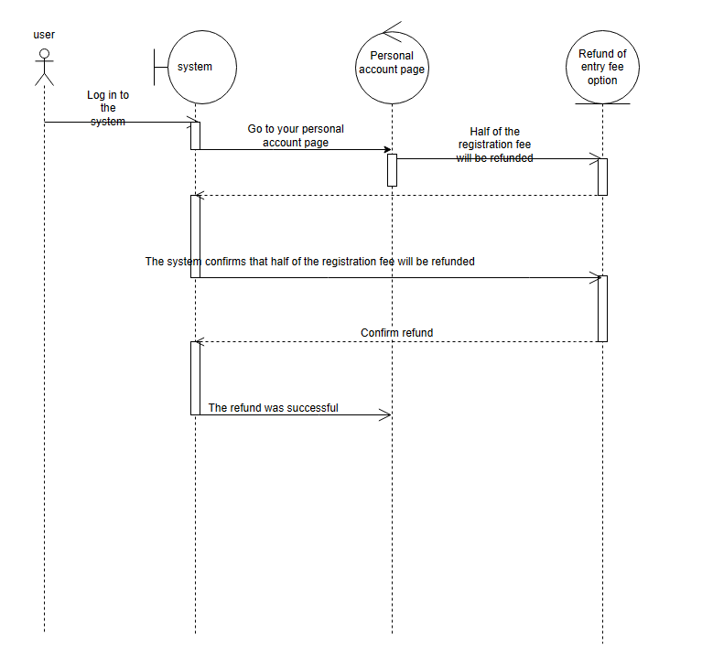

7.Execute a query

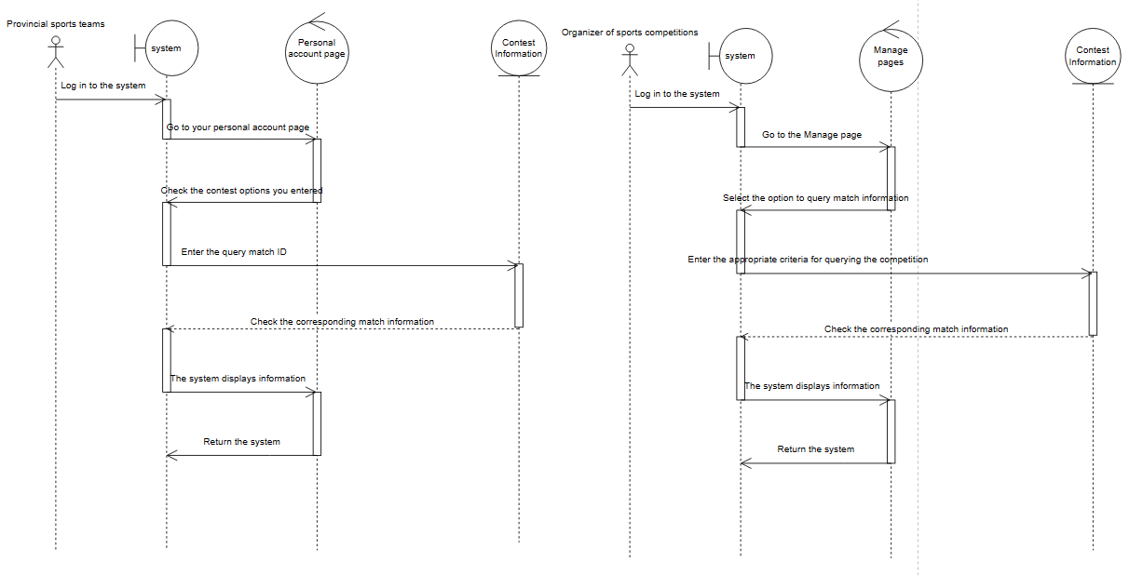

8.Exporting search results

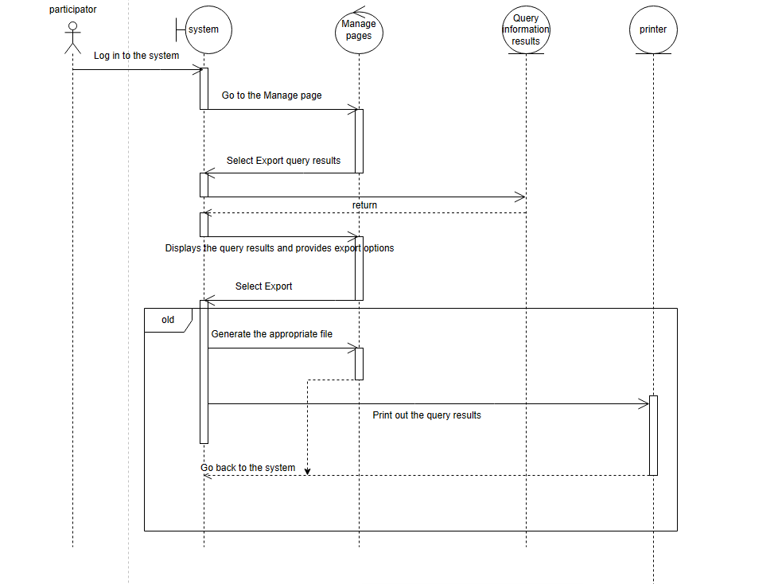

# **VIII. Persistence data ER diagram (Persistence data)**

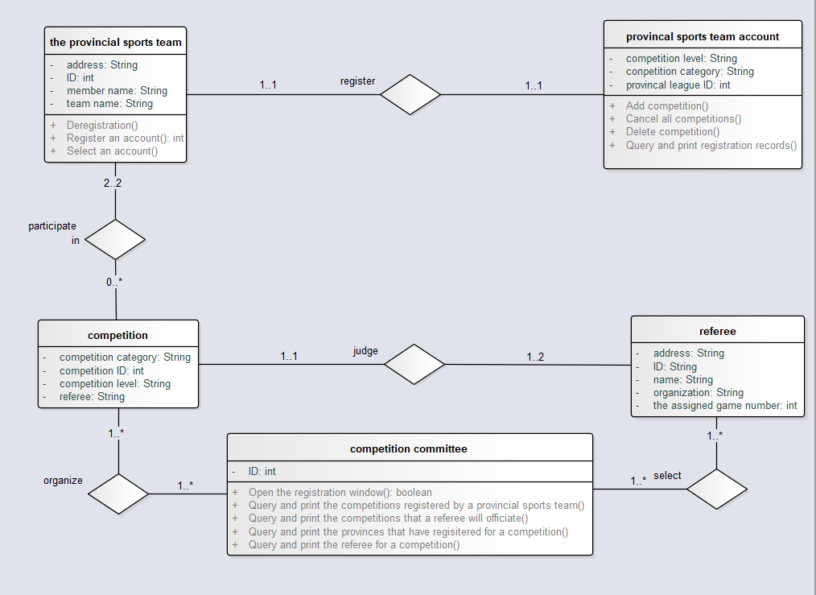

1. The provincial sports team has a unique primary key ID.
2. The provincial team account has the unique primary key provincial league ID.
3. The competition has a unique primary key competition ID.
4. The referee has a unique primary key ID.
5. Competition committee has a unique primary key ID.
6. Relationship set "Register" has a unique primary key provincial league ID.
7. The primary key of "Participate" in the relationship set is competition ID, the ID of team 1 and the ID of team 2.
8. The primary key of "Judge" in relationship set is competition ID and referee_ID.
9. The primary keys of "Organize" in the relationship set are ID and match ID.
10. The main key of "Select" in relationship set is referee_ID and committee_ID.

# **IX. Application deployment diagram**

